EXERCISE 2
1. Write the SELECT statement to extract the ids of employees who are more than 30 years of age.
SELECT emp_id FROM employee_data WHERE age > 30;
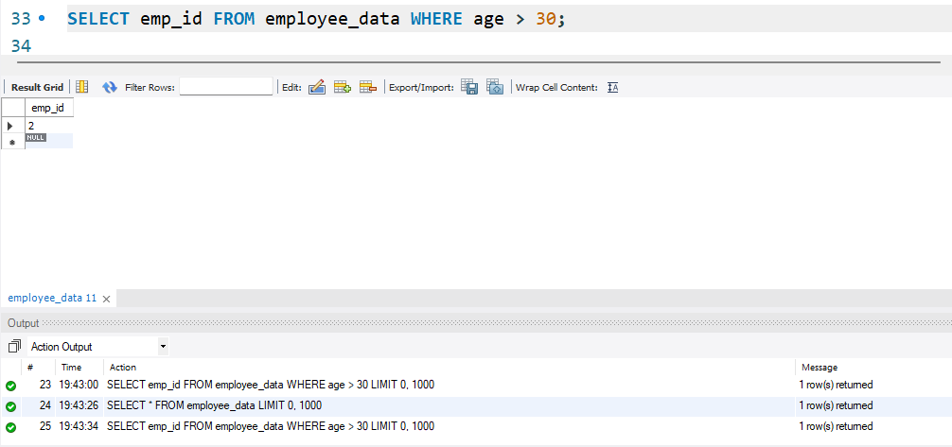

2. Write the SELECT statement to extract the first and last name of all web designers.
SELECT f_name, l_name FROM employee_data WHERE title = 'Web Designer';
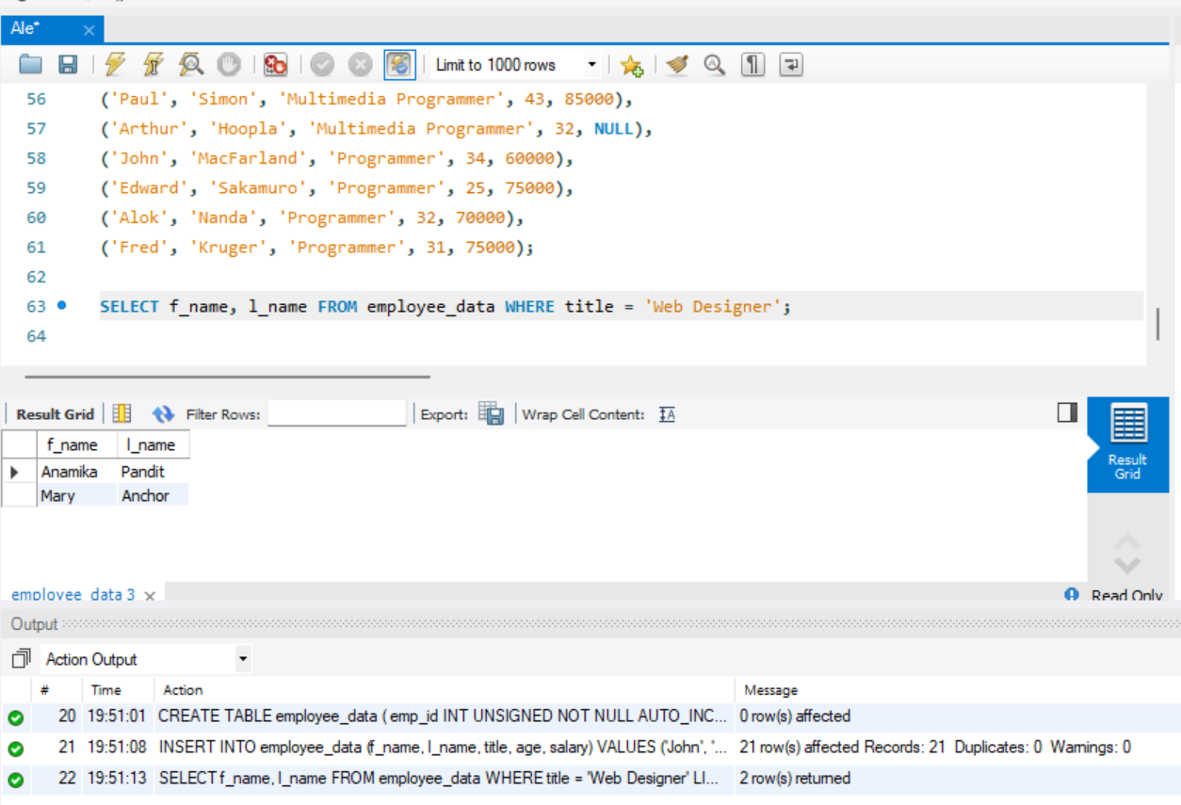

3. What will the following SELECT statement display:
SELECT * FROM employee_data WHERE salary <= 100000;
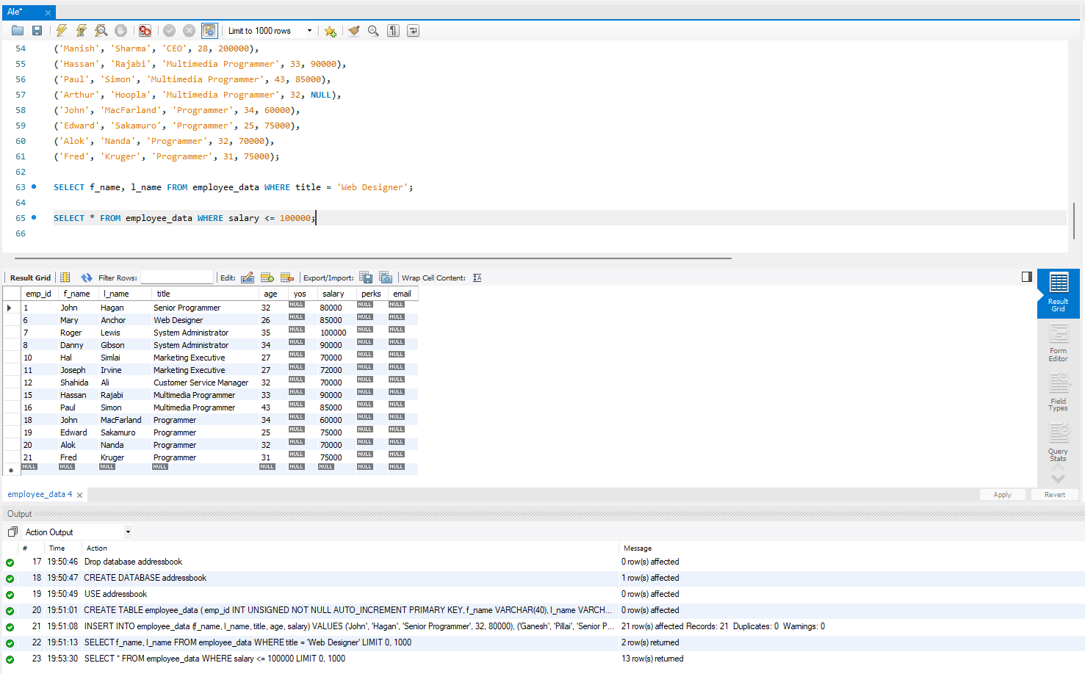

4. How will you display the salaries and perks for employees who have more than 16,000 as perks?
SELECT salary, perks FROM employee_data WHERE perks > 16000;
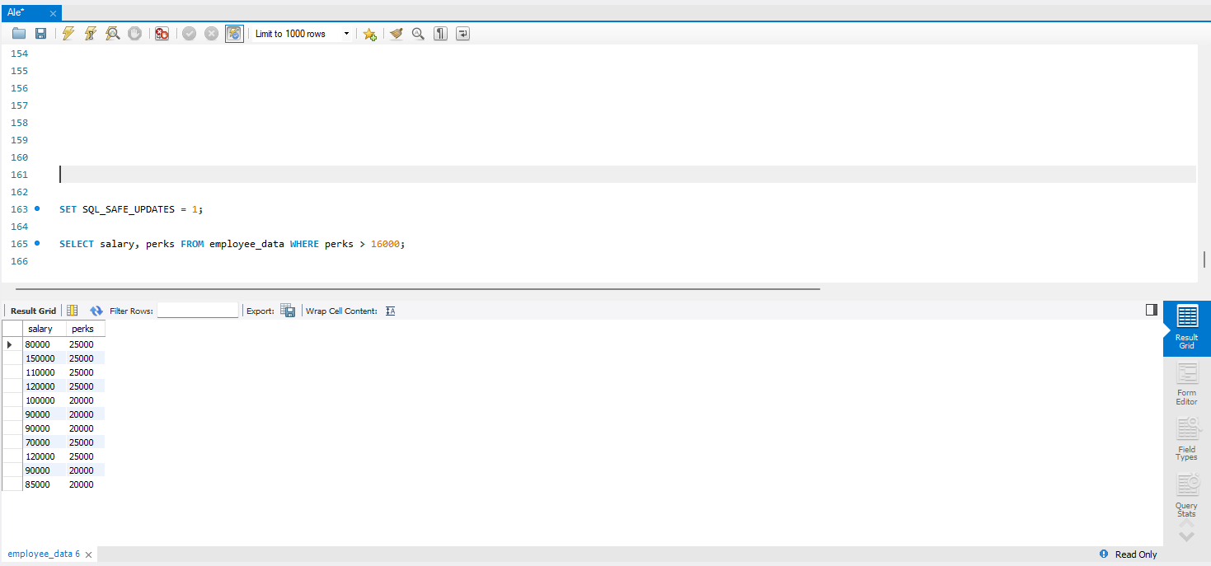
5. List all employee names (last name followed by first name) who hold the title of Marketing Executive.
SELECT l_name, f_name FROM employee_data WHERE title = 'Marketing Executive';
